The following tour has been planned for a group of Santo Domingo’s travelers in April 2013.

You can modify it as you prefer previously according with Silvana.

Good food !

SICILY GOURMET TOUR

This tour intends to visit the largest Island of the Mediterranean Sea, the kingdom of art, food and … good wine !
Created by chef Silvana Recupero together with Sicilian journalist-explorer Giovanni Vallone, this trip will allow the travelers to discover the wonders of this part of Italy, with an identity strong enough to be recognized worldwide almost as a separate nation, a world apart: Sicily is Sicily, Italy is a totally different thing !,Sicilians say proudly.
The Island saves, in the magnificence of its monuments and in its humus agriculus, thousands of years of history and dominations: Greeks, Romans, Byzantines, Arabs, Normans, Angevins, Swabians, Aragons, Bourbons; they all left something.
Temples alternate with theatres as well as the caponata (sweet and sour Arabic dish) alternates with the notorious pastries (cannolo, cassata …) of the island and its precious wine.
Do not forget to put in your suitcase, as well as the usual things, a fork, a glass and a fine cigar, Dominican obviously !
We wait for you at a table “cunzata” (laden)!

Silvana Recupero

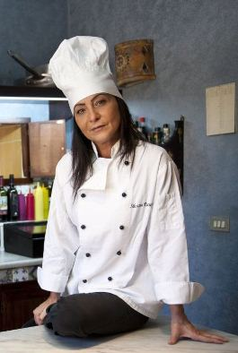

Sicily Gourmet tour:
the program
a trip to Sicily created by chef Silvana Recupero and the writer Giovanni Vallone

Every night the chef Silvana Recupero, Sicilian chef, will prepare a typical Sicilian menu, always including an appetizer, a main course, a second course and a sweet.
The tour will be a real tribute to Sicilian food. In addition to monuments and wine, of course!
- Dom 07 Aprile: Arrival and Welcome
- Arrival at the airport of Palermo according to the flight schedule.
- Transfer to the luxurious Abbazia Santa Maria del Bosco, in Contessa Entellina (in the province of Palermo), in the wonderful scenery of Western Sicily.
- Light Sicilian buffet prepared by the chef Silvana Recupero.
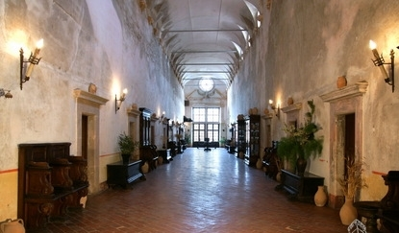
Abbazia Santa Maria del Bosco

- Lun 08 Aprile: Cooking Class, Cantastorie
- Breakfast
- Whole day in Agriturismo with Sicilian Cooking Lessons with the chef Silvana Recupero. We will mix, cut and cook … all together! During the Cooking Class will take place a little break with Sicilian Sweet and sweet wines, beloved by signora Silvana. Alternatively visit to Erice.
- Typical dinner with all the preparations of the pupils during the Cooking Class! With a little arrangement from the chef, of course!!!
- U’ Cantastorie, sicilian dances, songs and tales narrated by a storyteller
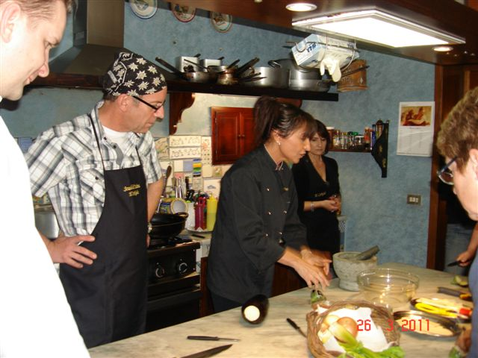

- Mar 09 Aprile: Cefalù, Cantina Sant’Anastasia
- Breakfast and start to Cefalù, wonderful medieval town spread on the sea. Norman Cathedrals, medieval streets, a beautiful museum and a Sicilian beach for diving lovers.
- Visit and tasting by Cantine Abbazia Sant’Anastasia, among the most important and famous vineyards in the world.
- Late afternoon: back to the agriturismo
- Typical Sicilian dinner prepared by the chef Silvana Recupero.

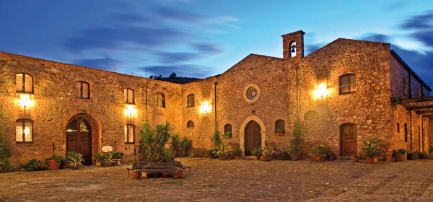
Abbazia Santa Anastasia. Wine tasting.

- Mer 10 Aprile: Greeks and Romans (UNESCO Tour), Wine tasting, Culinary Twinning

- Breakfast
- Move to Agrigento and visit to the monumental Parco dei Templi, UNESCO heritage of the V century B.C.
- Visit and wine tasting by Planeta – Cantina Ulmo in Sambuca di Sicilia.
- Late afternoon: back to the agriturismo
- Culinary Twinning: the chef Silvana Recupero together with the chef Gabriella Reginato will prepare a menu made with Sicilian and Dominican foods!
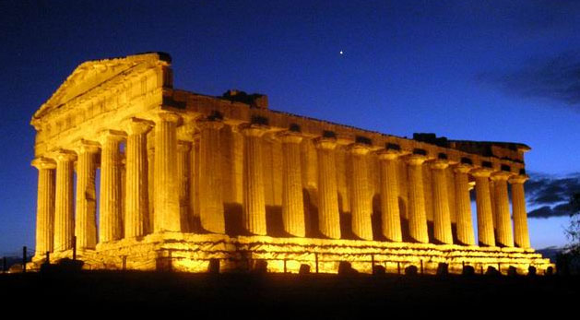

- Gio 11 Aprile: Palermo, Sicilian Muppets (Opera dei Pupi)

- Breakfast and start to Palermo, chief city of the island: wonderful city, among the most beautiful in the world. It offers the opportunity of walking through the downtown and the neighboroughoods, watching master pieces going back to 3000 years of history and about ten different peoples: prehistorical drawings, Phoenician walls, Arab-Norman buildings, gardens and traces of mosques, Aragon doors, Baroque style architectures, narrow streets and quarters with an Islamic footprint. We will discover Palermo also in its daily inner life, we mean its popular quarters of the Vucciria and Ballarò, a real Eldorado for Street Food lovers: prepare your belly!
- Opera dei Pupi, typical theatrical little Sicilian show representing the deeds of the paladins of Charlemagne (paladins of Christianity) against Saracens invaders.
- Late afternoon: back to the agriturismo
- Typical Sicilian dinner prepared by the chef Silvana Recupero.

- Ven 12 Aprile: A Sicilian festa

- Last day at Abbazia. Great Sicilian Feast.
Throughout the day are expected vendors of typical Sicilian products and objects who will alternate every hour.
H. 07.00 Ricotta cheese home made with bread and glass of red wine of the Madonie.
H. 09.00 Treasure hunt in the woods. You will win a typical Sicilian outfit, complete with a coppola !
Folk tarantella: Sicilian dances
H. 11.00 Cheeses and cold cuts, with a glass of wine of the Madonie.
H. 13.00 Sicilian dance competition.
H. 15.00 Fish grill (arrustuta), glass of white wine of the Madonie.
H. 17.00 Scopa tournament, typical Sicilian card game.
H. 19.00 Pasta al forno, Salsiccia and a river of wine with chants and dances.

ALL THE PROGRAM OF THIS DAY MIGHT CHANGE. FOOD, ACTIVITIES, WINES … MIGHT CHANGE. WILL BE A FESTA WITH FOOD, ACTIVITIES, WINES … THIS WILL BE SURE.
AND WILL BE A MOMENT TO STAY ALL TOGETHER BEFORE TO LEAVE THE ABBAZIA.

- Sab 13 Aprile: Etna, Taormina, Mammaciao !

- Breakfast and start to Mount Etna. Tour around the highest volcano in Europe.
- Accommodation to Ora Luxury Grand Hotel Villa Itria****, in San Giovanni La Punta (Catania’s province).
- Early afternoon: visit to Taormina, the pearl of the Sicilian tourism with its wonderful Greek Theatre and the famous streets full of amazing shops and cafè. The visit will be independent by the guide and you’ll have at about 3 hours of visiting.
- Typical Sicilian dinner prepared by the chef Silvana Recupero at MammaSicily’s headquarter, the reign of the chef. Farewell moments !!! Ciao ciao …

- Dom 14 Aprile: Ciao

- Breakfast
- Transfer to the airport according to the flight schedule.
PRICE: euro 1300 pp (minimum 20 pax)
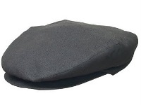
- Tickets included: Valley of Temples,
Opera dei Pupi, Wineries.

For more information please contact:
Alessandra Bai, tour manager
347 5642487 bai@mammasicily.com

SICILY: Via Roma, 1 - 95020 Aci Bonaccorsi (Ct) Tel (+39) 095 7890548
ROME: Via Magliano, 151 - 00060 Formello (Roma) Tel (+39) 06 9089789
Partita Iva 04085090878 (Ass Il CoNsole)
Cookery, chef Silvana Recupero chefsilvana@mammasicily.com (+39) 3476934643
Culture, doct Giovanni Vallone giovannivallone@mammasicily.com (+39) 3475913083
Press Office and Assistant, signora Alessia Castagna info@mammasicily.com (+39) 3407453567
Villas manager, signor Giuseppe Recupero mammasicily@mammasicily.com (+39) 3382327253
Tour manager, signora Alessandra Bai bai@mammasicily.com (+39) 3475642487
www.mammasicily.com www.ilconsole.it

